.
Mmac

Movement for married clergy
http://www.marriedclergy.co.uk

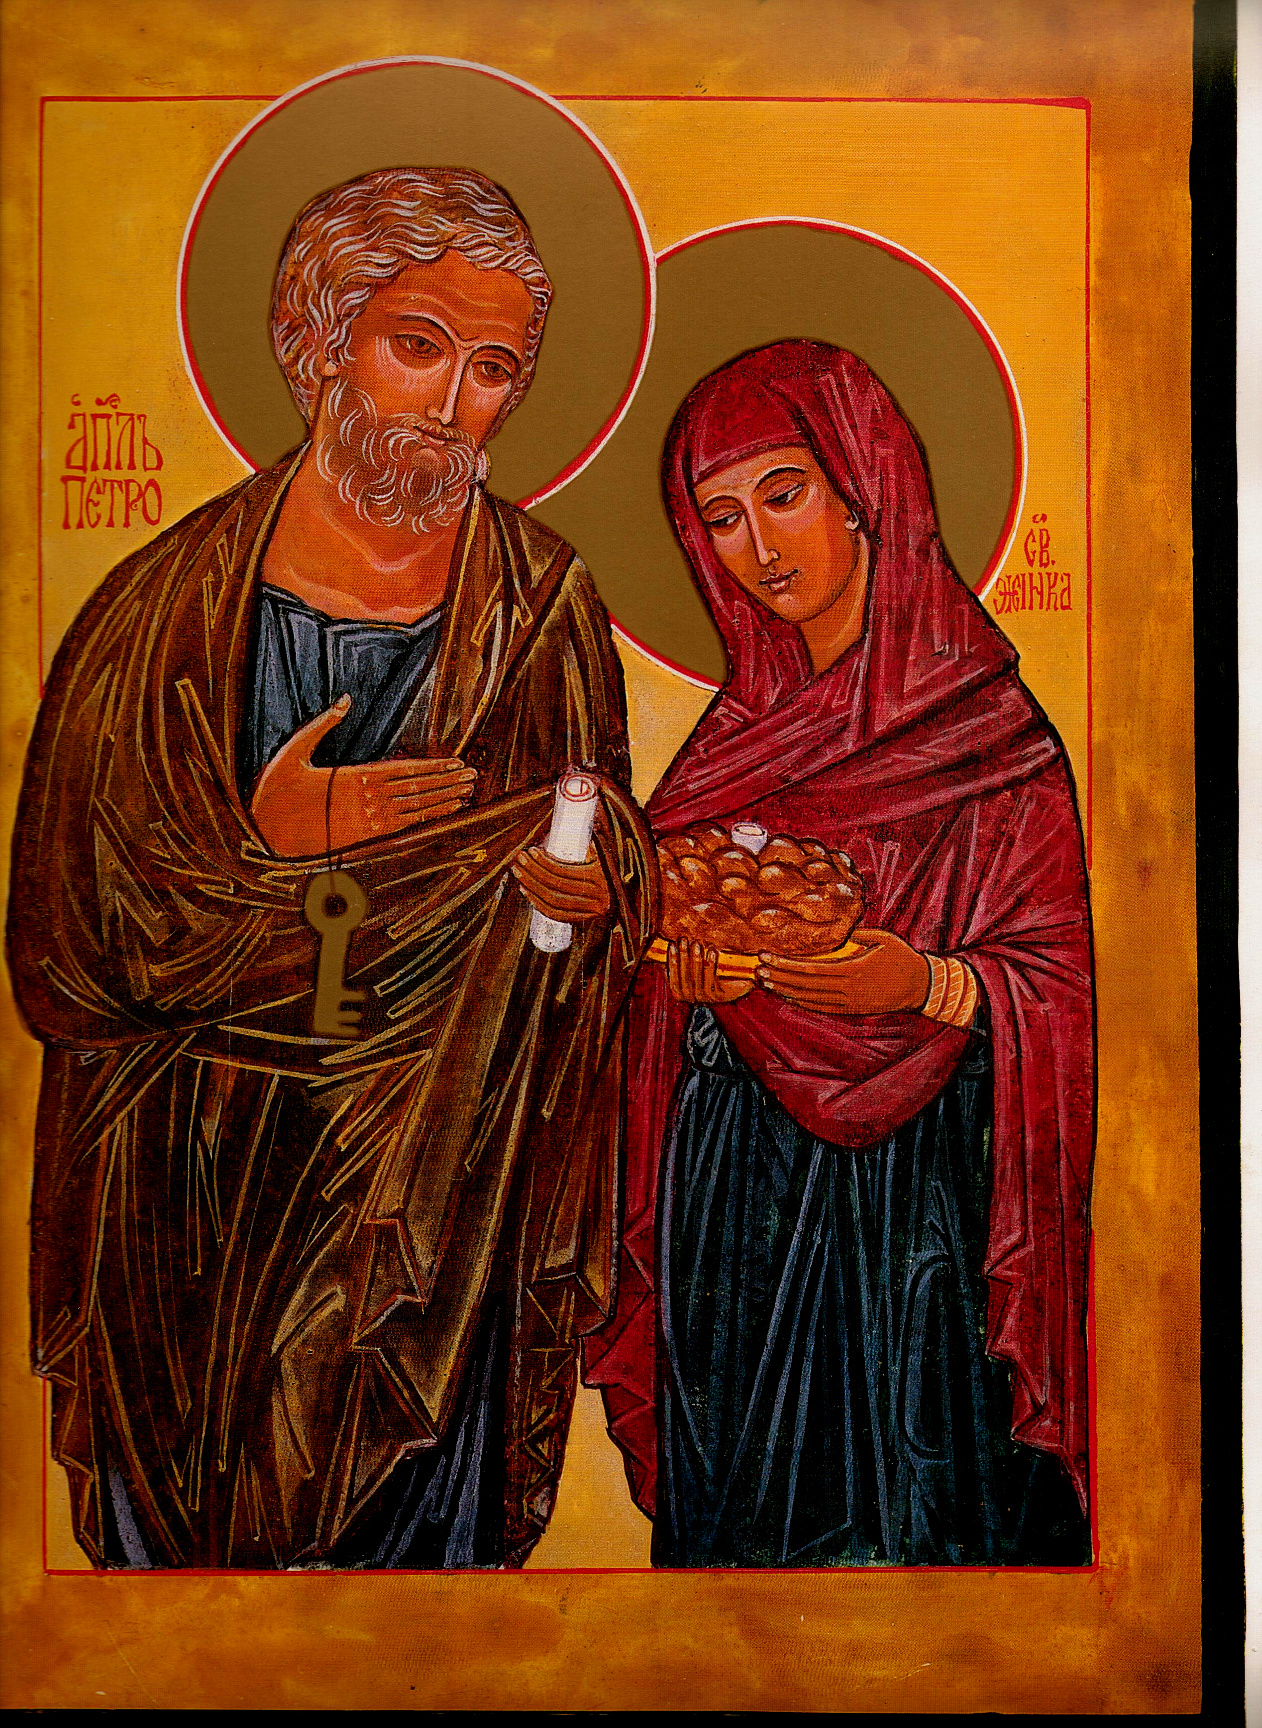

Chair Secretary

Mike Kerrigan Chris McDonnell
34 Bideford Gardens 1 High Chase Rise
Whitley Bay Little Haywood Staffs
NE26 1QP ST18 0TY

01 912 595 141 01 889 881 514

07970 86 85 57 07927 90 25 26
mkerrigan12@yahoo.com chris@mcdonnell83.freeserve.co.uk

St Peter & his wife: Eileen McCabe NYC: with permission

Members' Newsletter: March 2017

From the Chair-Mike Kerrigan

Things may at long last be starting to happen! Not on the home front, of course - or not yet. But it seems that the Brazilian bishops have responded to Francis' clear invitation, in answer to Bishop Kräutler, to come forward with imaginative ideas: according to the bishop's fellow Brazilian, Leonardo Boff, they have asked if some priests who have married could be re-admitted to ministry. The word - in many quarters - is that Francis is minded to agree to this, initially as a limited experiment in that country. But then, who knows? As Brendan Hoban ironically comments, 'You can see where this is going – the dreaded domino effect. First priests who are married, then married men who can be ordained, then a choice for a married or celibate clergy, then women deacons and eventually the unmentionable!'

Here in the UK, MMaC has so far concentrated on campaigning for the ordination of suitable married laymen (viri probati) believing, probably rightly, that this objective has a slightly better chance of success, in our context, than asking for the welcoming back of 'renegades', as some in the hierarchy have called them. Still, according to Advent, around 10,000 serving UK priests have left active ministry in the last fifty years or so. Even if only a small percentage, of those still living and practising, were able and willing to serve again, that would be a significant contribution to preventing the wholesale amalgamation of parishes that is currently happening. We all know of such men - and we often hear how warmly they would be welcomed back! In practical terms, they would operate just like the newly ordained married laymen who are MMaC's primary goal: having moved into secular work, or retired from it, these returning priests too would be self-supporting 'volunteers' - much less costly than the full-time ex-Anglicans, for instance. Should MMaC, therefore, make this aim (which is already expressed in our Mission Statement) more prominent in future publicity and action, alongside the ordination of 'viri probati'? The Committee think so - and propose to amend MMaC's Aims accordingly. But before we do, we'd welcome your views.

As for the rest of Brian Hoban's dominoes, well, even if the Irish bishops still don't get it, Francis does: piano piano, si va lontano, as we suspect our canny Pope may be thinking....

Request for volunteers

Dr Alana Harris*, history lecturer at King's College, London, has asked MMaC for assistance in her research project. Her aim is to 'explore the ways in which, for English Catholics, understandings of sin, sex and psychology shifted in Britain since Second World War'. She intends to 'interview around fifty English Catholics across the country about their experiences of love, marriage, family life and contraceptive practices between the 1940s and 1970s. The sample will include men and women, clergy and laity, practising and ‘lapsed’ and, if possible, gay and straight Catholics'. If you would be willing to contribute to this research, please contact Alana: She can be contacted at:
King’s College London, Strand, LONDON, WC2R 2LS
email: alana.harris@kcl.ac.uk
phone: 07780 601 469

*Alana Harris is the author of the important recent book, Faith in the Family: a lived religious history of English Catholicism, 1945-82 (Manchester University Press, 2013)

MMaC Website ( www.marriedclergy.co.uk )

Our website continues to attract visitors. Indeed recently 'hits' have increased - a sign of the times? Still, it could do with more expert management. Any volunteers?

eBulletin

If MMaC has an email address for you, you will, we hope, have received our first 'eBulletin'. The purpose of this, initially at least, is to bring relevant news items and other reading directly to members' attention. The eBulletin consists of links to the latest news plus other useful documents to download. The latter will include handouts which we have used in our talks to groups, articles, extracts from books, etc.

If you have received the eBulletin, we would appreciate your comments. Thank you for those who have already commented. If you'd like to receive the eBulletin but have not yet told us your email, then please do send it to either of the addresses at the head of this Newsletter.

Diocesan reorganisations

It is clear that most, if not all, English and Welsh dioceses have plans to reorganise. However, the information we have is piecemeal, gleaned from occasional news about individual dioceses. We need to able to get an overall view of the situation nationally. MMaC has approached the Bishops' Council, in the expectation that they would have gathered information about this - but, believe it or not, they haven't! BC just told us to approach individual dioceses. ACTA is also working on this topic, but it may time for their research to be published. Whatever optimistic gloss is being put on these reorganisations, it is obvious what makes them necessary is shortage of priests. MMaC therefore needs to be in possession of accurate data if we are to argue that such reorganisations are myopic, and that there are other ways forward - in particular married priests - which would be much more effective. Please, if you know or can find out, do tell us now what is happening in your own diocese.

Getting MMac's message out

Over the past year, MMaC has provided speakers for several local Newman Association meetings. These inputs have been very well received. We would like to expand this activity. If you know of any groups who would be willing to invite us to speak to them - and particularly settings where, unlike Newman, we would not be talking to the largely already 'converted' - we would be most interested to know about them.

Similarly, MMaC tries to ensure that our message is heard in the national Catholic press. A number of local diocesan papers have also published our articles and adverts. If you think that your diocese's paper would accept an article or ad, please let us know its name and who to contact.

From the Secretary-Chris McDonnell

We have continued in recent months in our attempt to open a meaningful dialogue with the Bishops of England and Wales. By and large, unsuccessfully. The usual pattern of non-response to letters does not reflect ‘the listening Church’ that we hear about from Francis. We offered the Tablet an article with that title a couple of weeks ago, an article which was rejected as being ‘too campaigning’. Publication of that piece is now awaiting the decision of the editor of the Pastoral Review.

Speaking in Belfast in mid-February, the Cardinal was quoted in the Tablet as saying “I value both the celibacy of the priesthood and the fact that it is restricted, as I would believe is the wish of the Lord, to men.” That remark seems to close the door on both issues.

In response this letter was submitted for publication-and rejected…

Published letters under the ‘Topic of the Week’ heading (February 25th) in response to the Cardinal’s recent comments in Belfast reflect the present impasse.
On the one hand we have the Cardinal expressing an entrenched opinion, and so influencing the views of English and Welsh
bishops, whereas on the other we have an alternative view that struggles to be heard.
Unless that large group we presume to label ‘laity’, something like 99% of the Church, have an opportunity to hold meaningful conversations with our bishops, we will continue walking into a future crisis that is painfully obvious to so many, but not apparently to those who determine the road we should walk.

How might we talk to each other?

We would urge all of those members who support MMaC to respond to Press articles to pursue our argument and particularly make contact with your Bishop to express your concern at the non-productive silence.

From the Treasurer
Please send in your subscription for this year which is now due. MMaC cannot function without sufficient funds to meet our running costs. Our current balance stands at just over £2,800

AGM 2017
We are currently exploring arrangements for AGM proceedings in London this coming Autumn. More details will be published in July.
Chris McDonnell Secretary MMaC

