Mmac

Movement for married clergy
http://www.marriedclergy.co.uk
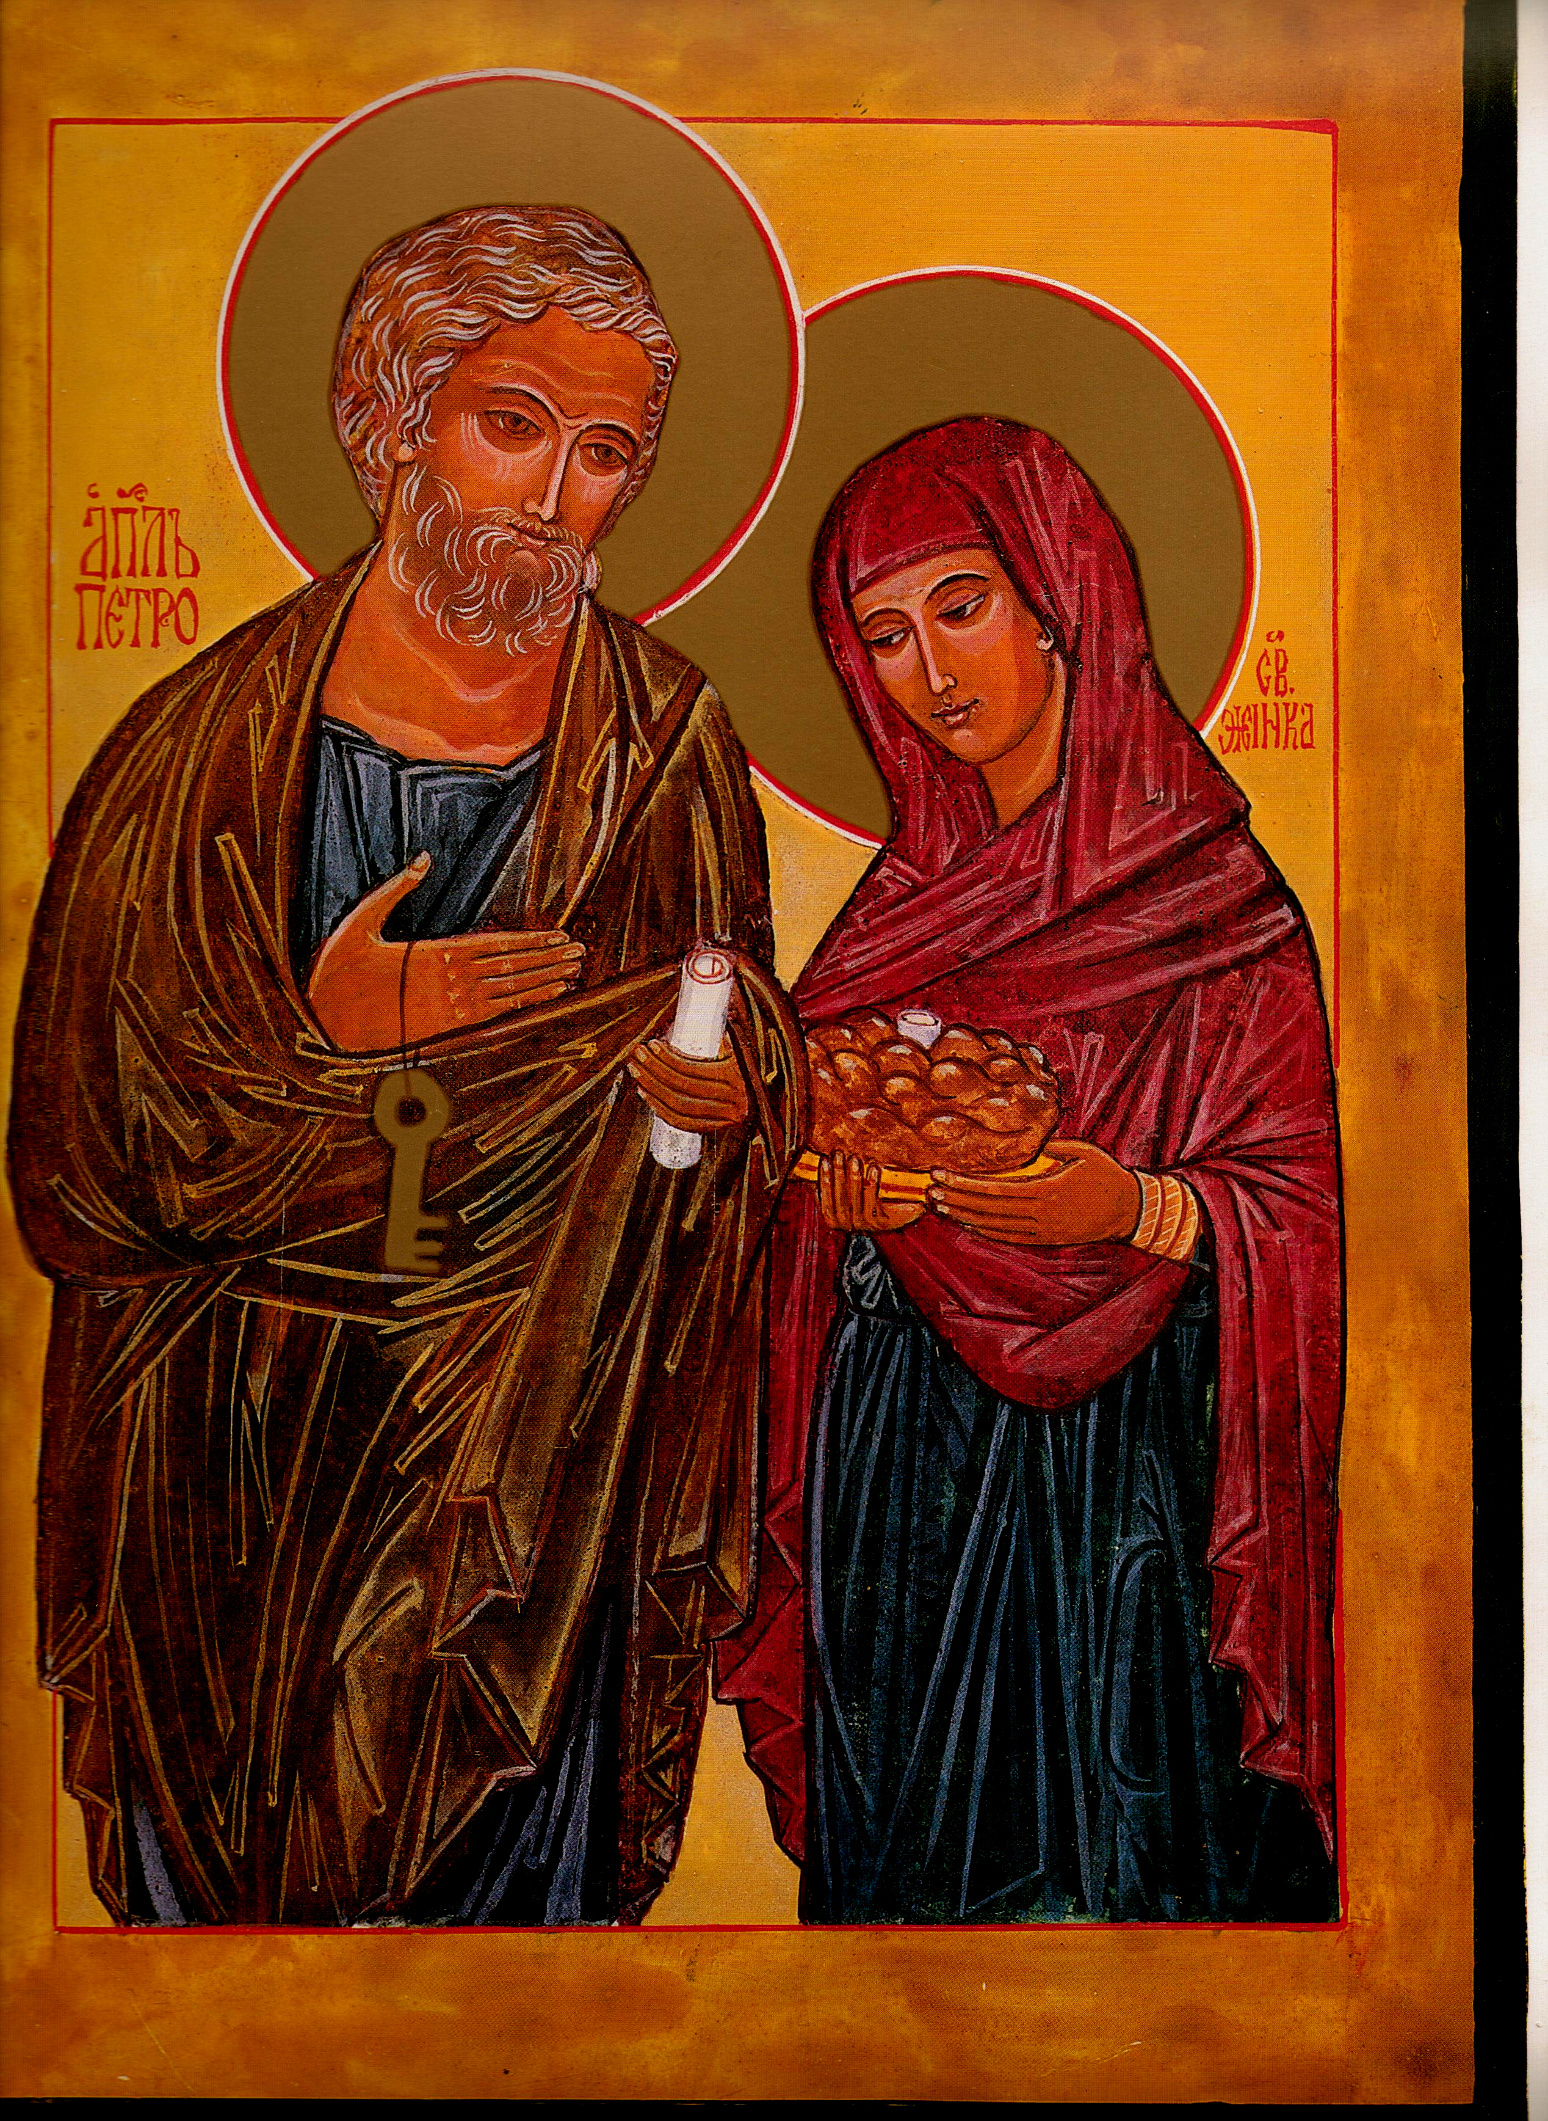

Chair Secretary

Mike Kerrigan Chris McDonnell
39 Cleveland Road 1 High Chase Rise
North Shields Little Haywood Staffs
NE29 0NW ST18 0TY

01 912 595 141 01 889 881 514

07970 86 85 57 07927 90 25 26
mkerrigan12@yahoo.com chris@mcdonnell83.freeserve.co.uk

St Peter & his wife: Eileen McCabe NYC: with permission

Members' Newsletter: July 2015

Change of Chair
At the AGM held in June of this year in York, Dr Michael Winter, our Chair for a number of years, announced his intention to retire for personal reasons. Michael has been involved with MMaC from its earliest days in the 70s, he has served on our Committee as Secretary for a number of years and more recently as Chair. It would be no exaggeration to say that without his guiding energy and sincere belief in the cause of accepting a married priesthood for the good of the Church, MMac would not only have been poorer without his leadership, but may not in fact have survived at all for so many years.
We thank you Michael and wish you every blessing and good health in the coming years. It goes without saying that he remains a member of MMaC. We are now privileged to have an “Emeritus Chair”.
His successor, chosen by the committee of MMaC, is Mike Kerrigan from the North East, whose professional background was in Education. Mike Kerrigan is a retired HMI (Her Majesty's Inspector of Schools). He trained for the diocesan priesthood in Louvain and Rome but, daunted by the lack of any preparation in the seminary for a life of celibacy - yet with the prospect of having to offer, from a position of ignorance, advice to the married laity - he abandoned this route and returned to England. After a linguistics degree at York, he started a career in language teaching and teacher training, first in Kenya, then in West Yorkshire. He joined the inspectorate in 1983, survived Ofsted and retired in 2001, but continued working in the modern foreign languages field until recently. A child of Vatican II, he admits to having gone quiet for a long period during the systematic repression of its message, waking up again only in the new century. He is also interested in travel, music and economics. Mike is married with three daughters and six grandchildren.
Since he joined us three years ago he has led the development of the website, the address of which is at the head of this Newsletter. He has created a valuable on-line resource of articles, letters and postings from not only this country but around the world. I am sure under his Chairmanship our Movement is in good hands.
Mike was instigatory in our adopting the Icon of St Peter and his wife on our letters and postings. He found the image on a book cover, contacted the iconographer in NYC and she gave permission for us to use it. Since then she has been generous enough to give the original icon to Mike on behalf of the Movement. We are indeed most grateful.

From the Chair
In February, Michael wrote that in the previous year MMaC had seen the most dramatic developments in its nearly forty-year history. Half-way through 2015, the drama continues: the Bishops' Conference of Brazil has set up a commission to consider ordaining married men; and more recent, very encouraging developments are described below. Times may indeed finally be a-changing. Still, our own UK hierarchies have yet to respond and show signs of that 'imagination' and 'boldness' which Francis invites: despite the huge and certain decline in the number of our priests over the next few years (just one ordination in Scotland this year!), they continue to hope that the Spirit will answer our old prayers, for an increase in vocations to the celibate priesthood. We should tell them that the Spirit may indeed be answering our prayers - but in a different way from what we expected: by inspiring us to take a first step 'out of the box' of tradition, seeking a new source of priests among our married laymen. Do take whatever opportunities present themselves to urge our bishops to imaginative boldness...
The coming year will see MMaC making two more contributions to the debate: a survey of ex-Anglican married priests, about their reception and new roles as Roman Catholics; and another to estimate the number of married laymen (viri probati) potentially available to be ordained priest, when the revolution comes.

New Committee Member
We welcome Joe Fitzpatrick from Ilkley in Yorskhire to the committee of MMaC.
We look forward to working with Joe and benefitting from his experience and theological knowledge. Other Committee members remain the same. On your behalf I thank them all for their time and effort.

Recent events
You may have read in the press of +Leo O’Reilly, an Irish bishop, who has recently gone public and asked the Irish Bishops Conference to examine the issues relating to a married priesthood in the light of the serious shortage of priests facing the Irish Church in the immediate future.
Following on from that becoming public knowledge, +Crispian Hollis, the Emeritus Bishop of Portsmouth, had a letter published in the Tablet (July 4th15) advocating that we begin consideration of the option of a married priesthood. In that letter he clearly indicated his willingness to support MMaC in whatever way he can. We are most grateful for his public statement in support of our aims and will continue to work with him in the coming months. In the July 11th copy of the Tablet there was an article of mine in support of +Crispian’s position and a letter from our Chair on the same matter. There is no doubt a sense of change in the air which we must encourage in whatever we can.

Website up-date
The website (now in a new and improved format) continues to attract an increasing number of visitors from all over the world - particularly, and perhaps significantly, from Brazil and the USA. It will shortly have a Blog facility, to which you are invited to contribute: let others know your views and start discussions about our objectives and the means to advance them. The Suggested Reading page has been supplemented with some very relevant articles by the speaker at our AGM, Professor Tom O'Loughlin. And there is now also a Contact Form which visitors can use to write to MMaC - and, incidentally, you can find on the website contact details for all the bishops of England Wales, active and retired. Just to remind you: we're at www.marriedclergy.co.uk

Subscriptions
The work of MMaC is funded entirely by members subscriptions. Our thanks for those who each year send in their cheques to keep us solvent. Sometimes through their generosity, we receive more than the subscription amount – our sincere thanks. Could I ask you if you have any subscription enquiries to contact our Treasurer, Bob Hughes, directly? His address is 11 Lawrence Leys Bloxham nr. Banbury OXON OX15 4NU. May I also on behalf of members extend our condolences to Bob whose wife died earlier this year. May she rest in peace.

Our recent AGM
After many years of holding the AGM mid-week in London, we sought a change this year and went to York on a Saturday. Unfortunately, as is the case with many Annual Meetings, the actual attendance was still very poor although we did have up to 15 apologies. It was a pity that more weren’t there on the day, for Tom O’Loughlin, professor of Historical Theology in the University of Nottingham gave a superb presentation on the nature of Eucharistic celebration in the early Church and the implications for priesthood. Notes relating to his talk are available on our Website. Tom has also given us access to many of his papers on the issues relating to celibacy and these have been made available on our website.

NE-MMaC - MMaC in the North-east
This group continues to meet to discuss issues national and local. Last time, a rather more general issue dominated, but one very relevant to our campaign: the widespread and (as one member put it) totally 'unprofessional' non-responsiveness of those in authority in the Church. Concerning the issue of married priests, but not only there, as ordinary catholics our attempts to communicate with bishops and others representing the Church are so often met with silence or, at best, prevarication. MMaC nationally, too, has long experience of this non-responsiveness. We recalled, in a similar vein, our abortive attempt last year to gauge lay opinion in our diocese about the ordination of married men: this did meet with a quick but negative response - but still, it was another example of our Church's seeming resistance to dialogue and transparency. Given the most recent developments - which clearly show the extent of support for the changes MMaC promotes - a proper survey of opinion, nationally as well as locally, is all the more appropriate. So is MMaC action at local level: if any members believe they could form a similar group of members in their diocese, do get in touch with us (mkerrigan12@yahoo.com) and we'll tell you how ours functions.

The coming year
Please continue to give the Movement your support, encourage people locally either through parish, deanery, or diocesan networks to join with us as we seek to support the mission of the Church by ensuring that we have priests to celebrate with us the Eucharistic meal that the good Lord left us.
If at any time you have any queries that I may be able to help with, please don’t hesitate to phone me or email me.

Chris McDonnell Secretary MMaC July, 2015.

STOP PRESS.
_________________________________________________
As we are about to print this newsletter, this week’s TABLET has been published – July 11th. It has considerable coverage of the issues related to married priests-now available on our website.

